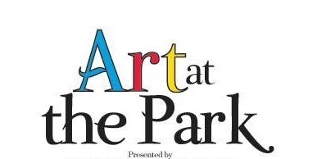

Forest Park Country Club

Sponsorship Request Form

Art at the Park will be held on November 1 and 2, 2019 at Forest Park Country Club to help the growing art scene in Martinsville-Henry County. This event is a fundraiser for Forest Park Country Club.

The $250 sponsorship fee affords you the opportunity to advertise in our program, on a sign in the foyer and a 2’x2’ sign on the white wall where the golf carts are located. We will need your logo emailed to Catherine Wingfield at wingfields@embarqmail.com no later than October 7, 2019.

Company Name: ________________________________________________

Contact Name: _________________________________________________

Address: _____________________________________________________

Telephone Number: ______________________________________________

Email address: _________________________________________________

Date: _____________________ Date Paid: __________________________

We would like to thank you, in advance, for your support to our Forest Park Country Club community.

